NC No: 19329 |  |  | DATE :02/06/2026 | NC STATUS  (tick when NC closed)
AREA/DEPARTMENT |  |  | QACC PURCHASE /  HAIDARI TRADING CO WLL
AUDITOR (OBSERVER) Name / Staff number: |  |  | QUALITY ASSURANCE DEPARTMENT
AUDITEE (HOD) Name / Staff Number: |  |  | QACC PURCHASE /  HAIDARI TRADING CO WLL
NONCONFORMITY OBSERVED |  |  | EVIDENCE (attach images below)
NC 19329 “Baby slug found in Lollo Rossa lettuce”  Receiving date  31/05/2026 |  |  | Please see below |  | Severity ( tick)
 |  |  |  |  | High | Medium | Low
 |  |  |  |  | 
Clause Number (or SOP) | PRP Perchase mangement  FOBs and Quality  WFSG 2022 V5 |  | HIGH – breach of a CCP or OPRP. Propose CA within 48 hours  MEDIUM – non fulfilment of a PRP or any SOP. Propose CA within 72 hours  LOW – Opportunity For Improvement. Propose new process within 96 hours
CORRECTION (action taken to contain the situation) |  |  | ROOT CAUSE
Existing stock in the warehouse was inspected through random sampling and opening of selected Lollo Rossa lettuce heads to verify the presence of worms or other pest infestation.  A briefing was conducted with the preparation staff to communicate the complaint and reinforce the importance of thorough inspection and careful preparation of leafy vegetables prior to dispatch. |  |  | The presence of the baby slug is due to the natural biological conditions associated with agricultural production. While pest control measures are implemented at the farm level, they are intended to minimize pest activity and cannot completely eliminate all pests from fresh produce.  Lollo Rossa lettuce has a dense and tightly packed leaf structure, which creates hidden areas where small pests can remain undetected. During the quality inspection process, personnel perform visual checks on accessible surfaces of the product. Due to the limited visibility within the inner leaves and the small size of the slug, it was not identified during the standard inspection.
PROPOSED CORRECTIVE ACTION (action taken to address the root cause to ensure no re-occurrence)
- Preparation staff were reminded to exercise greater care and vigilance during the preparation and handling of Lollo Rossa lettuce.  - Additional random sampling and leaf separation inspections were implemented for Lollo Rossa lettuce to improve detection of any concealed pest infestation within the dense leaf structure.  - Quality control personnel were instructed to increase attention to leafy vegetables with tightly packed leaves during receiving and preparation inspections. |  |  |  |  | Responsible
QACC PURCHASE /
HAIDARI TRADING CO WLL

 |  |  |  |  | Target date of completion
 |  |  |  |  | 04/06/2026
 |  |  |  |  | Actual date of completion
 |  |  |  |  | 04/06/2026
NC ACCEPTANCE |  |  | CORRECTIVE ACTION
AUDITEE (HOD) SIGNATURE / DATE |  |   Salvador Vallente  5/6/2026 | ACCEPTED (tick) |  | REJECTED (tick & add comments)
AUDITOR (QA Dept.) SIGNATURE / DATE |  |  | AUDITOR (QA Dept.) SIGNATURE / DATE
VERIFICATION COMMENTS: AUDITOR (QA Dept.): |  |  | Documents Verified |  | Signature & Date
NC CLOSED ACCEPTANCE |  |  | FOOD SAFETY TEAM LEADER / MANAGEMENT REPRESENTATIVE SIGNATURE / DATE
AUDITOR (OBSERVER) SIGNATURE / DATE
AUDITEE (HOD) SIGNATURE / DATE

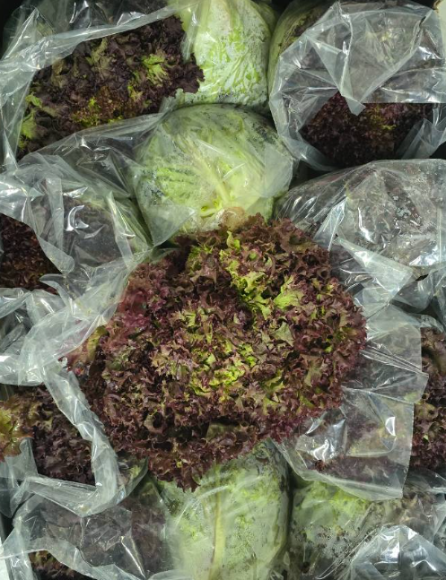 | 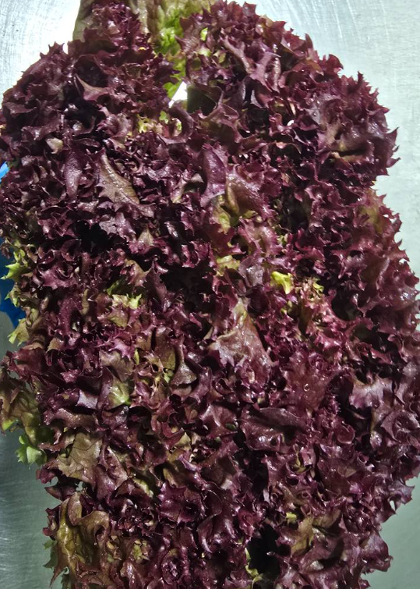
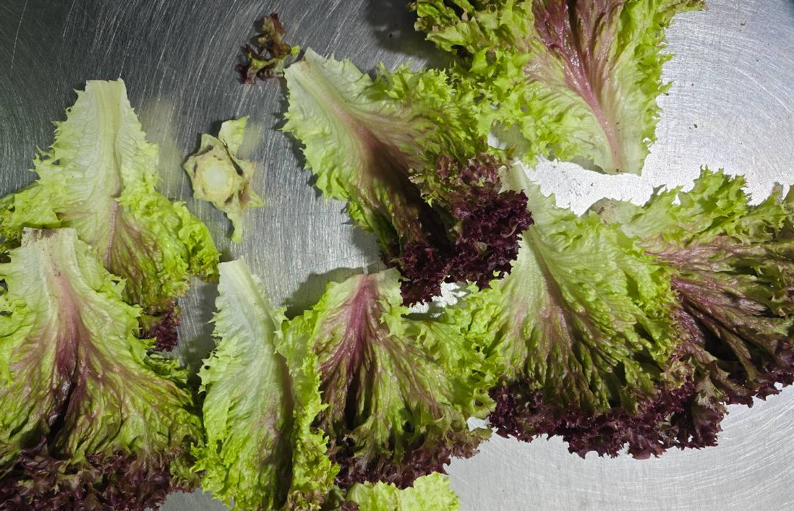 | 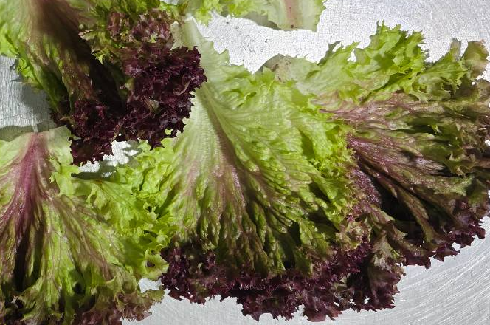
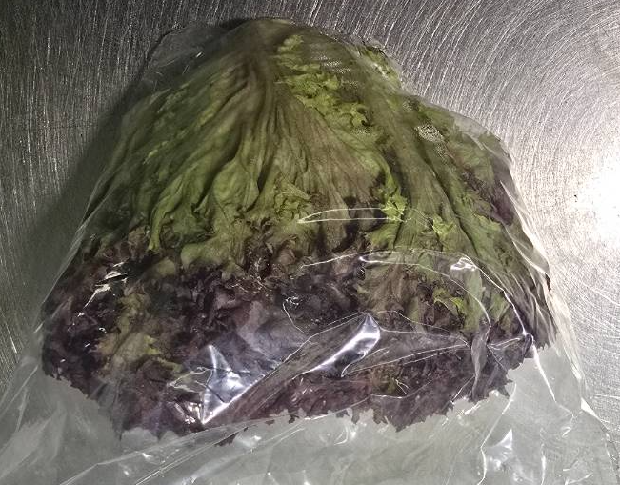 | 