NC No: 19330 |  |  | DATE :02/06/2026 | NC STATUS  (tick when NC closed)
AREA/DEPARTMENT |  |  | QACC PURCHASE /  HAIDARI TRADING CO WLL
AUDITOR (OBSERVER) Name / Staff number: |  |  | QUALITY ASSURANCE DEPARTMENT
AUDITEE (HOD) Name / Staff Number: |  |  | QACC PURCHASE /  HAIDARI TRADING CO WLL
NONCONFORMITY OBSERVED |  |  | EVIDENCE (attach images below)
NC 19330 “Quality issue observed in green apple”  Please note: NC raised with reference to complaint received from lounge  Receiving date  01/06/2026 |  |  | Please see below |  | Severity ( tick)
 |  |  |  |  | High | Medium | Low
 |  |  |  |  | 
Clause Number (or SOP) | PRP Perchase mangement  FOBs and Quality  WFSG 2022 V5 |  | HIGH – breach of a CCP or OPRP. Propose CA within 48 hours  MEDIUM – non fulfilment of a PRP or any SOP. Propose CA within 72 hours  LOW – Opportunity For Improvement. Propose new process within 96 hours
CORRECTION (action taken to contain the situation) |  |  | ROOT CAUSE
Check the available stocks in the store.  Briefed team regarding the complaint and the requirement of QACC about green apple. |  |  | The marks and blemishes observed on the green apples are primarily attributable to the natural characteristics of fresh agricultural produce. Green apples are cultivated in open-field environments and are continuously exposed to natural factors such as weather conditions, handling during harvesting, transportation, and contact with branches, leaves, and other fruits. As a result, minor superficial skin marks and cosmetic blemishes may occur and are considered normal within the fresh produce industry.  Although sorting and grading procedures are conducted before dispatch, the current cosmetic specification requires a very high level of visual perfection. Based on routine grading activities, only approximately 15–20% of the available product consistently meets these strict cosmetic requirements. This limitation is due to the natural variability of the fruit rather than deficiencies in handling, storage, or quality control processes.
PROPOSED CORRECTIVE ACTION (action taken to address the root cause to ensure no re-occurrence)
- The rejected green apples were replaced with a new batch that underwent additional sorting and quality checks prior to delivery.  - Enhanced grading and selection procedures were implemented to remove fruits with visible marks and blemishes exceeding the customer's cosmetic expectations.  - Find better available green apple with less cosmetic issue. |  |  |  |  | Responsible
QACC PURCHASE /
HAIDARI TRADING CO WLL

 |  |  |  |  | Target date of completion
 |  |  |  |  | 04/06/2026
Actual date of completion
04/06/2026
NC ACCEPTANCE |  |  | CORRECTIVE ACTION
AUDITEE (HOD) SIGNATURE / DATE |  | 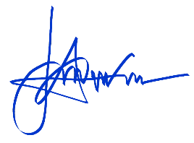  Salvador Vallente  5/6/2026 | ACCEPTED (tick) |  | REJECTED (tick & add comments)
AUDITOR (QA Dept.) SIGNATURE / DATE |  |  | AUDITOR (QA Dept.) SIGNATURE / DATE
VERIFICATION COMMENTS: AUDITOR (QA Dept.): |  |  | Documents Verified |  | Signature & Date
NC CLOSED ACCEPTANCE |  |  | FOOD SAFETY TEAM LEADER / MANAGEMENT REPRESENTATIVE SIGNATURE / DATE
AUDITOR (OBSERVER) SIGNATURE / DATE
AUDITEE (HOD) SIGNATURE / DATE

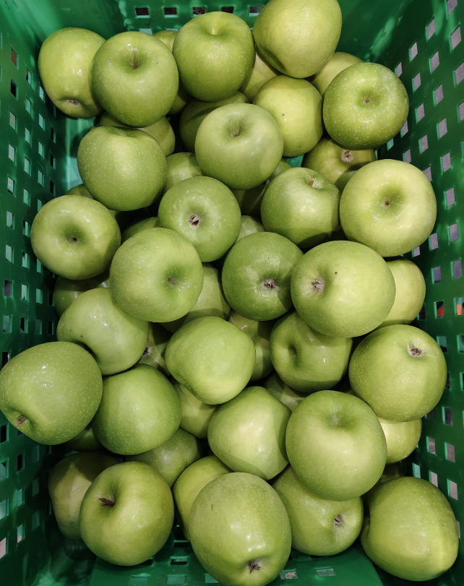 | 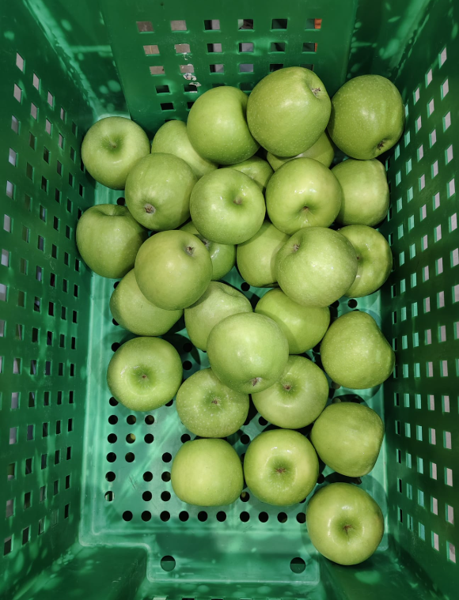
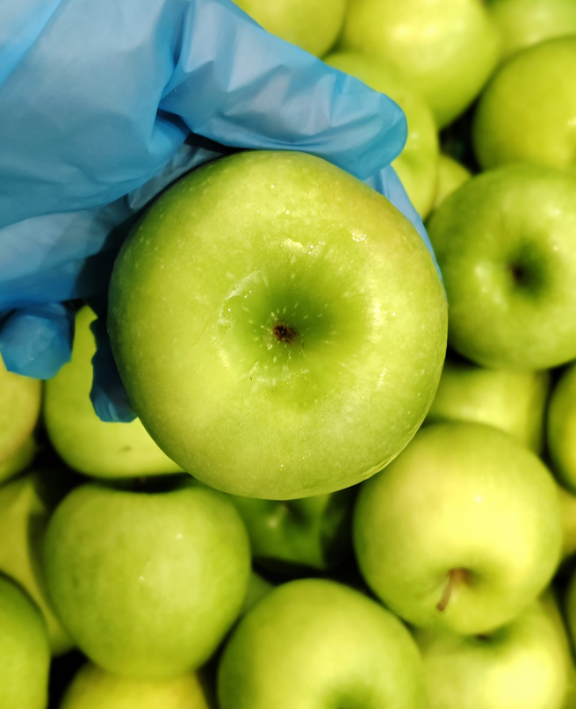 | 